Assignment 3

a)
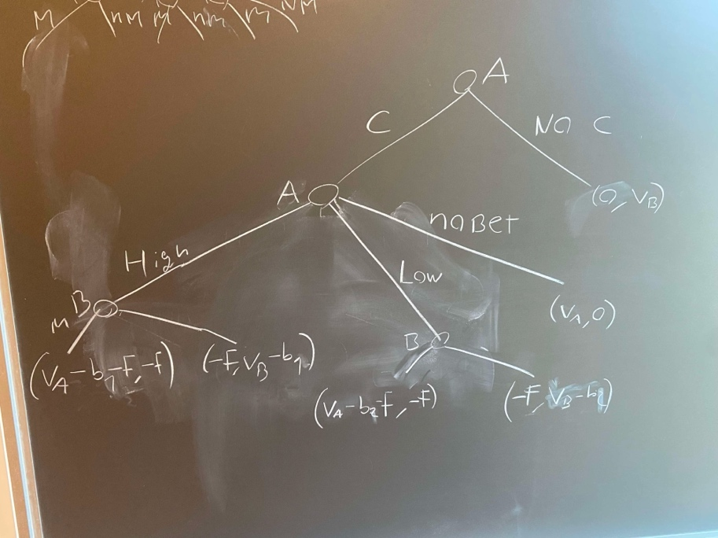
We write up the game
b)
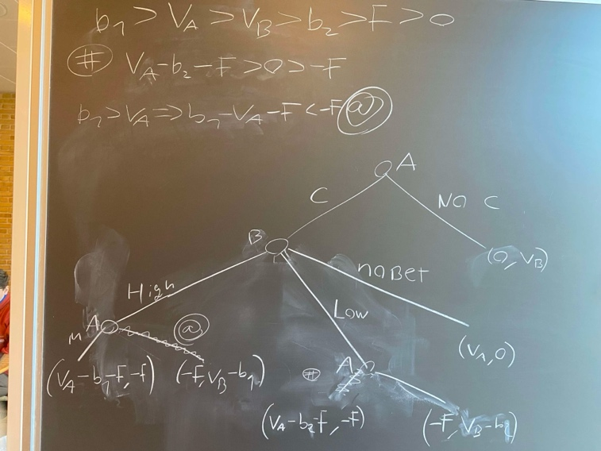
Then solve it with backwards induction step by step
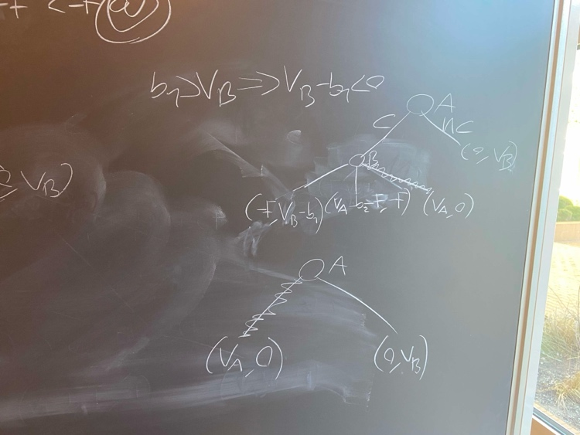

c)
now the game becomes a little more complicated
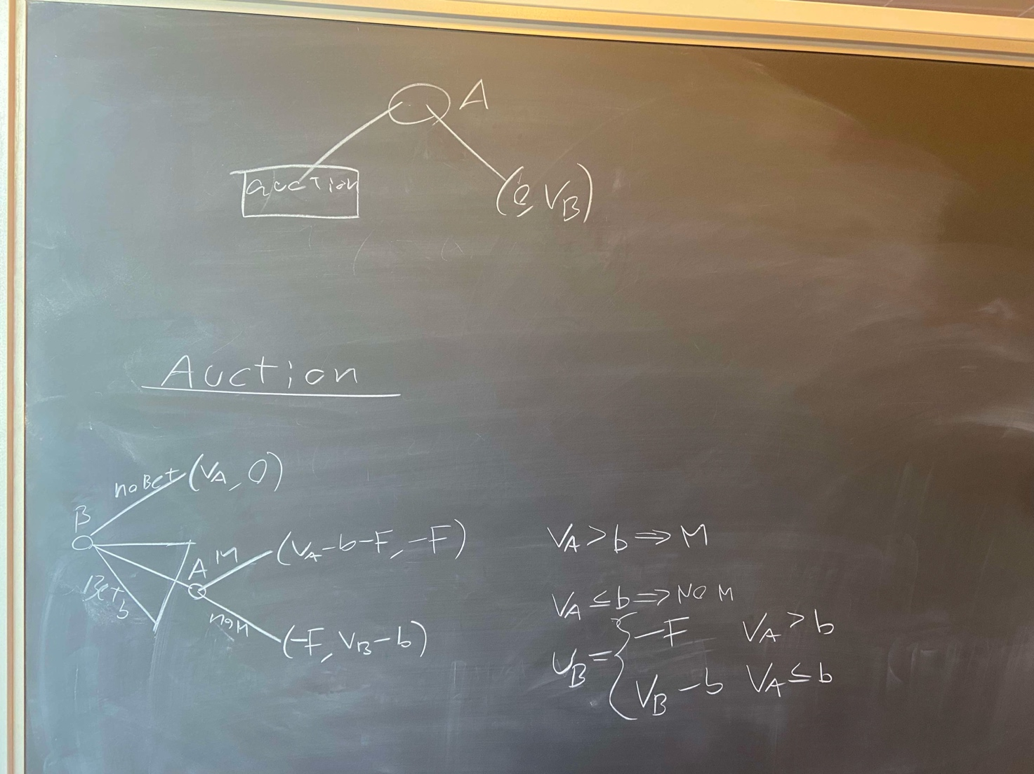
We write up the game as follows

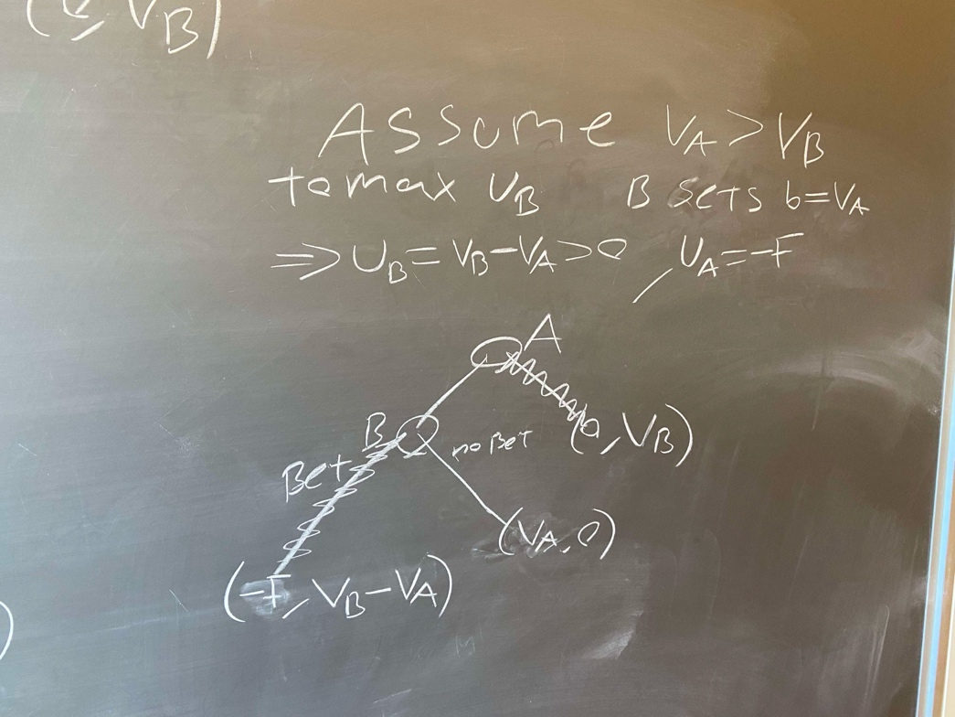
In this one ive assumed the opposite of what I wanted in reality it should be a “assume $V_{A}<V_{B}$

d)
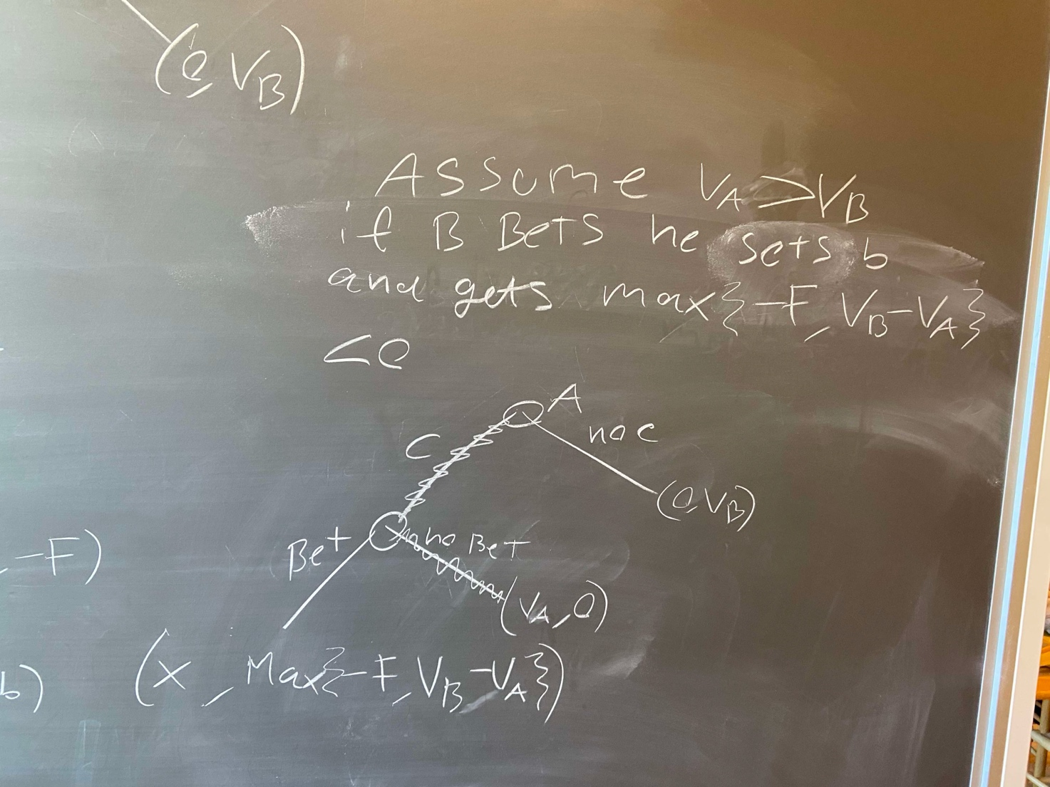
e)
we notice that in both equilibria no fee is payed and thus it simply makes each player be “not indifferent between entering and not entering if no Fee player B can simply place a bet that he is willing to pay and force A to pay for his item even though its his watch (under this assumption)

